This letter is private and confidential.


DATE
Name
Address 1
Address 2
Postcode

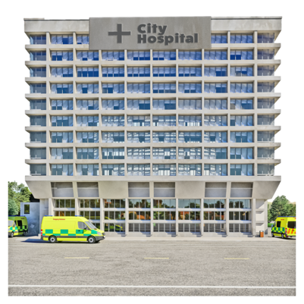
Dear xxxx

Why we are writing to you
Your doctor told you today you need to go to hospital to have some checks.
You need to be seen urgently within 2 weeks.
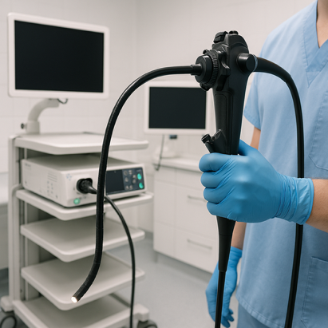
- See a specialist to have a test – this might be a test with a camera


Why you need this check
We need to check you don’t have a serious condition like cancer.
Most people who have this check do not have cancer. But we need to check early so we can give you treatment if you need it.

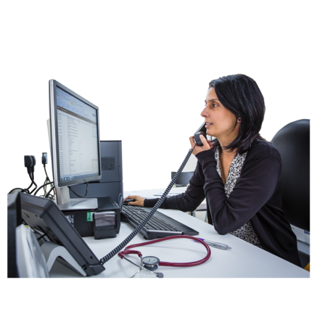
What happens next
The hospital will get in touch to set up an appointment.
Please call your GP if you haven’t heard anything in 10 days.
It is very important you go to your appointment.

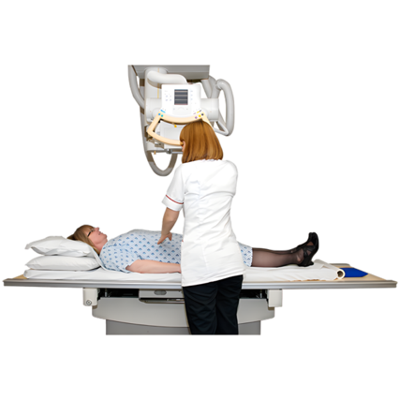
Tests you might have
You might need to have
- blood tests
- X-rays
- scans on your body
- camera tests

We will tell you what you need to do before the appointment.
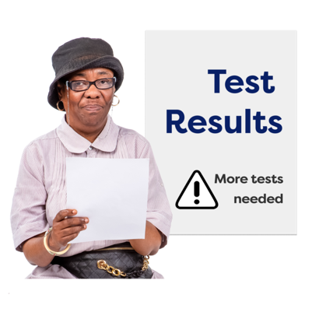
What happens after the tests
You will get the results on the same day.
The specialist at the hospital will talk to you
- about your results
- what happens next


You can bring someone with you if you want to.
This can help if you have questions or want to talk about your results more.

If you have any questions about the tests, then please contact your GP.

Or you can go to this website
http://www.cancerresearchuk.org/cancer-symptoms/what-is-an-urgent-referral


You can keep doing normal activities like exercise while you are waiting for the tests.
If you do need treatment, then it helps if you keep fit and healthy.


Thank you for reading this letter

Your GP

