Greater Manchester Cancer Alliance
Breast Cancer Treatment Summary

Document Control
TITLE OF DOCUMENT | Breast Cancer Treatment Summary
DATE DOCUMENT PRODUCED | 10 March 2025
DOCUMENT VERSION NUMBER | V2.0
AUTHOR/S | Claire Liu  Clinical Nurse Specialist, Manchester University Foundation Trust  Chair of Greater Manchester Cancer Alliance Breast Nursing and AHP Forum  Claire Goldrick  Pathway Manager, Greater Manchester Cancer Alliance
WHICH PROGRAMME / PATHWAY BOARD / GROUP HAS PRODUCED THIS DOCUMENT (IF APPLICABLE) | Breast Pathway Board  Breast Nursing and AHP Forum
WHAT CONSULTATION HAS TAKEN PLACE? | This document has been developed in collaboration with the breast pathway board, Greater Manchester Breast Nursing and AHP Forum and the Breast Cancer Small Community
HAS AN EQUALITY IMPACT ASSESSMENT BEEN COMPLETED? | No – NA for this document
HAVE THE ENVIRONMENTAL  SUSTAINABILITY IMPACTS BEEN  CONSIDERED AND ADDRESSED? | NA
REVIEW DATE | March 2027

For GP use only: please code this letter as cancer treatment completed:
Snomed code 413737006 | Cancer hospital treatment completed (situation)
8BCF.00 | Read | Cancer hospital treatment completed​
GM Cancer standard template for primary breast cancer treatment summary
Please delete this title and box after reading these instructions.
Remove all wording that does not apply to a particular patient in order to personalise it to the individual.
If you need to localise this treatment summary, eg job titles do not match those used in your Trust or adding your Trust logo, please do so, but please retain all other information.
Remember to ensure sections don’t overrun onto the next page or titles separate from the body of the text before sending.

Patient Name:  Patient Address: | Hospital Name:  Hospital Address:  Date of Birth: 00/00/0000
Hospital No: 01234567
NHS No: 999 999 9999

Dear [INSERT PATIENT NAME]
Thank you for attending your [INSERT CLINIC NAME] appointment on [INSERT DATE].
Please find below the summary of your diagnosis, treatment and the ongoing management plan that we discussed. A copy of this has also been sent to your GP. Everyone’s management plan is different, as it is based on their diagnosis and treatment. This plan is specific to your needs.
Our (Insert local Trust service name) has been designed to increase your knowledge about breast cancer, support your wellbeing and to help you move forward now that your initial treatment has finished. Please remember that if you do feel anxious or would like further advice at any time you are welcome to contact your Breast Care Nurse who can recommend a wide range of resources and services that have been designed to help you.
Key Contact Numbers:
Breast Care Nurse | Name:  Contact Number:
Breast Cancer Care Coordinator | Name:  Contact Number:

Diagnosis and Treatment to Date:
Diagnosis: | Please give full details | Date of Diagnosis:
Histology:

Summary of Treatment and relevant dates:
Please be specific and give full details, avoiding jargon. Include ongoing treatment e.g. endocrine therapy/bisphosphonates

Treatment aim:

Further Treatment and Management:

Further Management [delete as appropriate)
- Self-supported management / consultant annual follow up (delete as appropriate)
- You will be called for an annual clinical appointment.
Due XXX (add details or delete as appropriate)
- You will be called for a mammogram +/- MRI every year for 5 years following diagnosis.
or until your 50th birthday. Last performed / due XXXX

- Identified as eligible for extended surveillance mammograms and will have annual mammograms until age 70 . Last performed / due XXXX
- Gene carrier that has been referred to VHR NHSBSP (breast screening programme) for mammogram +/- MRI up to age 70 referral made by ……… ……....(consultant)
- Bone density (DEXA) scan [add details]
- Menopausal Blood Clinic appointment requested
- Medical illustration form given for patient who have had reconstruction

If you have any concerns about breast symptoms between mammograms it is important that you contact your Breast Care Nurse.

Possible Side Effects from the treatment(s) you have had:
Some side effects can improve quickly. However, some side effects such as fatigue, may take longer to improve. If you are struggling to cope with side effects, or if the side effects are getting worse rather than better, please contact your Breast Care Nurse for advice.
[Delete if not appropriate)

Possible side-effects from surgery:
- Changes in the look and feel of the breast, chest wall or armpit due to scarring from surgery.
- Numbness and/or long-term pain/discomfort around the site of surgery and upper arm.
- Swelling/Fluid build-up in the arm, hand or breast (lymphoedema) - please contact your Breast Care Nurse if this occurs so that they can arrange further assessment. Lymphoedema is a common side effect from breast cancer surgery. There are steps you can take to reduce the risk of developing lymphoedema. Your Breast Care Nurse can provide you with further information.

Possible side-effects from endocrine treatment:
- Hot flushes
- Aches and pains in joints
- Feeling of tiredness or exhaustion (fatigue)
- Mood swings
- Reduced libido (sex drive)
- Vaginal dryness
- Patients taking tamoxifen have an increased risk of developing blood clots. Please seek urgent medical advice if you have pain, redness and swelling in a leg, are breathless or have chest pain.
- Tamoxifen slightly increases your risk of developing endometrial (womb) cancer if you are post-menopausal (have gone through the menopause). . If you are pre-menopausal (have not gone through the menopause), then taking tamoxifen does not increase your risk of developing cancer of the womb. If you have any abnormal vaginal bleeding (not related to a period) you should speak to your breast care nurse or GP to be referred to a gynaecologist.
- Aromatase inhibitors can increase risk of developing osteoporosis (thinning of the bones). All patients on aromatase inhibitors should take vitamin D tablets (colecalciferol 800-1000 units).

The ovarian suppression service may supervise your endocrine treatment if you are under 40 and are receiving ovarian suppression (goserelin or leuprorelin injections). They will give further advice and address any issues about side effects at your appointment: [add contact details].

Possible long term effects from radiotherapy:
- Changes to colour of skin where treatment has been given.
- Tiny visible blood vessels on the skin surface (often called ‘spider veins’ or ‘telangiectasia’)
- Breast/ chest wall / armpit may remain tender or sensitive
- Swelling/fluid build-up in the arm, hand or breast (lymphoedema)
- Changes in size or shape of breast
You should have been provided with the ‘Radiotherapy after surgery’ booklet and a copy of the your radiotherapy consent form at the time. Please refer to these for more detailed information.

Possible long term effects from chemotherapy:
- Feeling of tiredness or exhaustion (fatigue) that can last for several months after chemotherapy treatment ends
- Difficulty with concentration and memory that can last for 1-2 years after treatment
- Tingling, numbness or pain in fingers and toes (peripheral neuropathy). This may slowly resolve with time but can be permanent for some patients.
- Increased risk of starting natural menopause early or difficulty getting pregnant naturally
- Rare risk of developing second cancers
- Heart problems
- Inflammatory changes in the lungs
- Hair thinning
- Permanent hair loss is a rare side effect

Possible long term effects from HER2 directed therapy:
- Feeling of tiredness or exhaustion (fatigue)
- Inflammatory changes in the lungs
- Heart problems – your heart will be carefully monitored whilst undergoing this treatment.

If you are taking HER2 treatment, you will be followed-up by the HER2 therapies team. They will give further advice and details and address any issues at your appointment. [add contact details]

Possible long term effects from Targeted Therapies:
- Feeling of tiredness or exhaustion (fatigue).
- Inflammatory changes in the lungs

If you are taking any targeted treatment, you will be followed-up by the breast oncology team. They will give further advice and details and address any issues at your appointment. [add contact details].

Possible long term effects from Immunotherapy:
- Feeling of tiredness or exhaustion (fatigue)
- Hormonal disorders including thyroid issues, adrenal issues, pituitary issues, diabetes.
- Bowel disturbance
- Inflammation of the lungs, heart, kidneys pancreas or muscles
- Hepatitis (liver inflammation)
- Rashes and skin reactions

If you are taking immunotherapy treatment will be followed-up by the breast oncology team. They will give further advice and details and address any issues at your appointment. [add contact details].

Possible side effects from Bisphosphonates:
- Feeling of tiredness or exhaustion (fatigue).
- Flu-like symptoms. These symptoms should improve after a short time. However, you may find it helpful to take paracetamol on the day of the infusion and for a couple of days afterwards.
- Damage to the bone of the jaw (osteonecrosis of the jaw). This is a rare side effect that usually occurs after dental disease or invasive dental procedures that expose the jaw bone. If you have persistent jaw pain, loose teeth, swelling, redness or ulcers on the gums you should inform your Breast Care Nurse and see your dentist urgently.
- Thigh bone (femoral) fracture. This is a rare side effect. If you have persistent pain in your thigh, hip or groin, you should inform your Breast Care Nurse.

If you are taking bisphosphonate treatment, you will be followed-up by the Adjuvant Bisphosphonate Service. [add contact details].

Additional information relating to lifestyle and support needs:

What can be done to reduce the risk of breast cancer returning?

- Maintaining a healthy weight: Your risk of a future breast cancer increases if you are overweight after the menopause.
- Reducing alcohol intake: There is strong evidence that alcohol intake increases the risk of future breast cancer
- Regular physical activity: There is strong evidence that being physically active reduces the risk of future breast cancer
- Stopping smoking: Cancer is more common in smokers

Your Breast Care Nurse can give you details of support with any of the above.

National Breast Screening Programme:
Once you have completed your breast cancer follow up (usually 5 years of annual mammograms) you should continue to have mammograms every 3 years through the National Breast Screening Programme:
- The national breast screening programme invites women aged 50-70 for a mammogram every 3 years. If you are over 70 you can still attend screening mammograms, but you have to ask to participate - please speak to your GP or the breast screening service for more information.
- If you are under 50 at the end of your cancer follow-up, you will continue to have mammograms with your breast cancer team until you reach the age of 50 and then you will be invited to join the national breast screening programme.
- If the breast cancer you have been diagnosed with has been caused by an error in one of your genes, you will have mammograms +/- MRI scans under the high risk national breast screening programme until age 70. You will remain under the care of the breast unit for 5 years for any other follow up.
- If you have had both breasts removed (a bilateral mastectomy) and are invited for breast screening, ask your breast screening unit for an opt-out letter or your GP can write to the Breast Screening Unit to inform them you do not require screening.

Symptoms of possible recurrence that will require investigation:

(Delete infographic as appropriate)

Recurrence is uncommon but occasionally breast cancer can return in the breast, chest wall or armpit (local recurrence) or in a different part of the body (metastatic breast cancer).

If you notice any new lumps in your breast (either side), armpit, or mastectomy scar, or new changes to the breast shape, skin or nipple, it is important that you contact your Breast Care Nurse to arrange assessment.

It is important that you remain breast and body aware. Get to know your own body by looking and feeling, so that you know what is normal for you.

Local Recurrence:
If you notice any of the following changes, you should contact your GP:
- A new lump in the breast (either side), mastectomy scar or armpit
- Skin dimpling / change to breast shape
- New in-drawing of your nipple
- Clear or blood-stained nipple discharge that comes out without squeezing

Metastatic Breast Cancer:
The image below shows the possible symptoms of secondary breast cancer. If you experience these symptoms for more than 3 weeks, with no obvious other cause (e.g. a common cold, a back injury etc) they need to be reported to your Breast Care Nurse or GP.

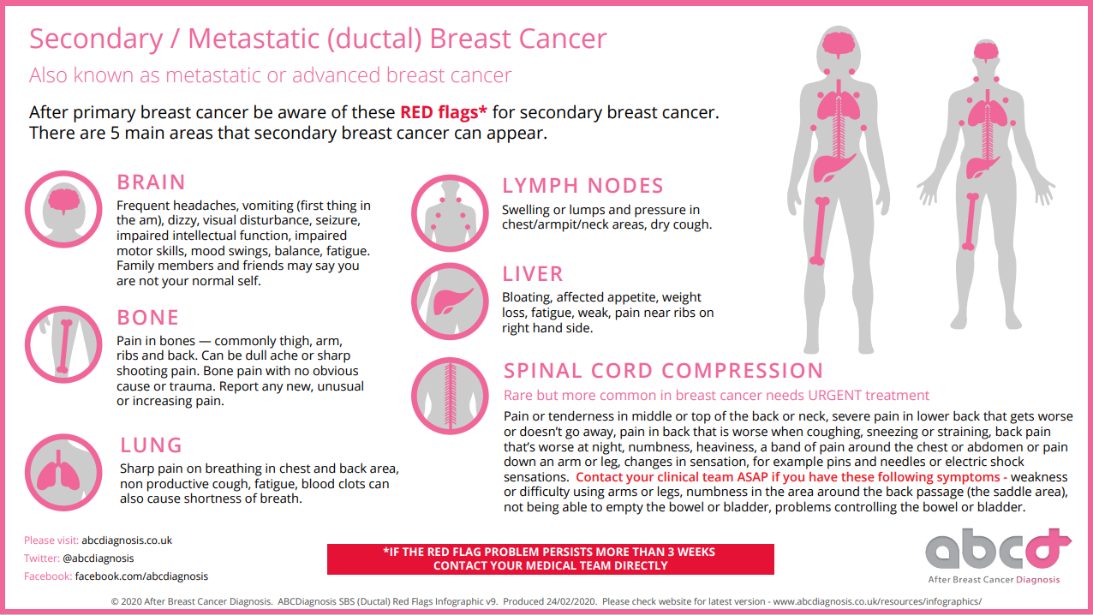

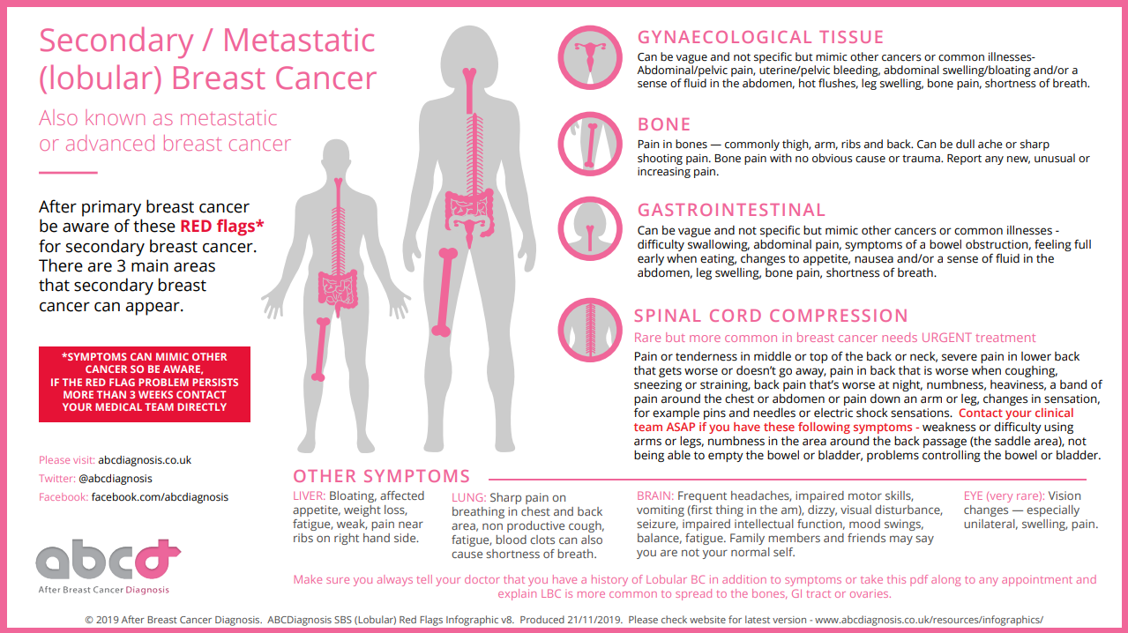

Treatment Summary Completed by:
Signature:
Copy sent to GP:
Copy sent to Consultant:
Copy sent to other Health Care Professional(s): | [Insert details]

ADDITIONAL NOTES FOR GP
For GP use only: please code this letter as cancer treatment completed:
Snomed code 413737006 | Cancer hospital treatment completed (situation)
8BCF.00 | Read | Cancer hospital treatment completed​

Personalised Care and Support Plan □ (attached)

Health and Wellbeing Information and Support given | [Insert details]
Prescription Charge exemption certificate □ | Free prescription reminder □
Advice given on services available on prescription | [Insert details]
Advice given to apply for Personal Independence Payment (PIP) | Yes/No/Not applicable

Will [INSERT PATIENT NAME] be self-managing? | Yes / No [Delete as appropriate]  [If no, state reason]
Advise entry onto primary care palliative or supportive care register? | Yes/No/Not applicable
SR1 application completed? | Yes/No/Not applicable
Prescription Charge exemption certificate | Yes/No/Not applicable
Referrals (e.g. reconstruction, lymphoedema, physiotherapy):
Required GP actions (e.g. ongoing medications/ osteoporosis screening)
Cancer Care Review

Follow instructions as per oncology treatment summary on completion of adjuvant treatments.

Please continue to prescribe until (month/year)

All treatment summaries are subject to review in light of evidence-based changes to clinical protocols and treatment toxicity.
Additional resources and information for primary care staff are available through www.gatewayc.org.uk

