Psychological Support and Mental Health Delivery Group Patient and Carer Representative

This is an outline of what your role will involve. You will have the opportunity to discuss this in more detail with our team as part of your induction.
Role Title
Psychological Support and Mental Health Delivery Group Patient and Carer Representative
Location
Hybrid/flexible.
Delivery Group meetings generally tend to happen online using MS Teams with 1 face to face meeting per year. We will work with you to find the best way to support you should this be a problem.
How often | Any additional time commitment?
Usually 4 meetings a year  Delivery group meetings tend to be 2 hours long | Yes – time to read papers and respond to emails, approximately 2 hours extra per meeting.
Tenure (length of commitment) | Experience required
Two years tenure (with opportunity to reapply in future if desired) | No formal experience required.
Supported by | Remuneration
Patient and Public Involvement and Engagement Team  Personalised Care Team | For any in-person events, we will reimburse you mileage plus car park fee or public transport fare, submitted via our expenses form
Selection Process
Applicants are invited to submit an expression of interest via email to gmcancer.voices@nhs.net by 7th June to be considered for this opportunity.
Expression of interest should include your reason for applying and key skills you feel you would bring to the role of Psychological Support and Mental Health Delivery Group Patient and Carer Representative.
These will be reviewed by the PPIE team and Personalised Care team. Where more expressions of interests than places are received, the best suited individual will be appointed based on how closely your skills and experience match those listed in this role profile. Please note that this criteria may vary according to the experience of other representatives currently or historically sat on the board – it is not a reflection of you as an individual.
Where we think you may be better suited towards other roles within the alliance, we will direct you towards these and provide support with getting involved.

Why we need your help
The Psychological Support and Mental Health Delivery Group has recently moved under the Personalised Care Workstream with the Greater Manchester Cancer Alliance (formerly a pathway board). The group is made up of multi-disciplinary professionals and patient representatives from across the cancer system to improve whole pathway for psychological care from diagnosis, through treatment, cancer rehabilitation, recovery, living with and beyond cancer and end of life care. This includes, but is not exclusively, psycho-oncology teams who share expertise across the whole pathway, including consultation and training with primary care and “Talking Therapies” services.

The purpose of The Delivery Group is to improve the psychological support and mental health aspects of cancer care for patients on Greater Manchester cancer pathways.

The Delivery Group will represent the interests of local people with cancer or living with and with and beyond their disease, whilst respecting their wider needs and concerns.

The Delivery Group will promote equality of access, choice and quality of care for all patients within Greater Manchester, irrespective of their individual circumstances.

We currently have one Patient Representative but are seeking another Patient and/or Carer Representatives to join the Psychological Support and Mental Health Delivery Group. These two representatives will work together to represent the collective views of patients and carers at the meeting by identifying appropriate areas for contribution, and to hold the group accountable to the work they have committed to.

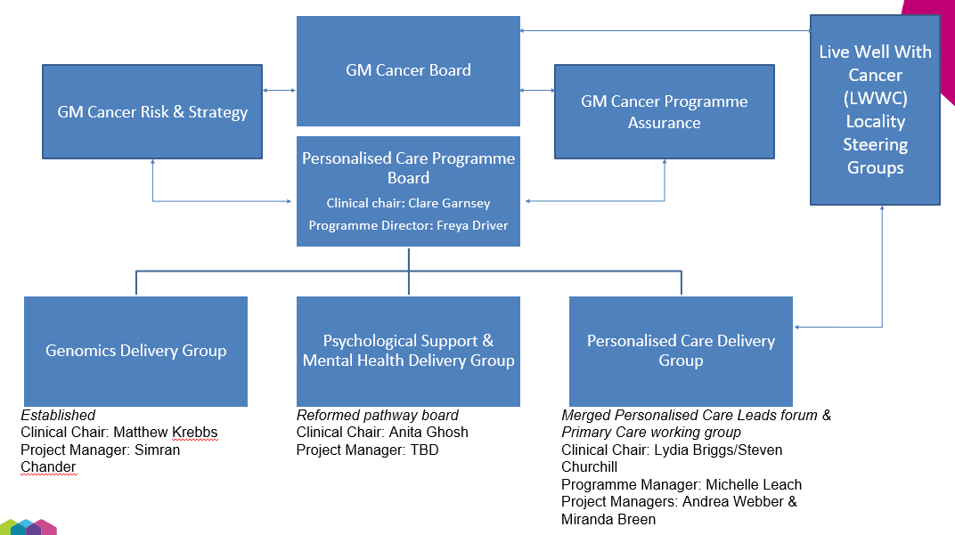

What experiences or skills do you need?
Essential
You have:
- Experience, as a patient or carer, of using any cancer services within the 10 localities of Greater Manchester, in the past or present.
- An interest in working collaboratively to improve the experiences of people affected by cancer in Greater Manchester.
- An understanding of the psychological needs of different people living with cancer.
- A general understanding of the pressures and difficulties facing healthcare delivery currently, and the impact this can have on patient services and experience.
- An awareness of and commitment to equality and diversity.
- An understanding of the need for confidentiality.

You can:
- communicate your ideas to a wide range of people including senior healthcare professionals in the most appropriate way.
- reach out and engage with people affected by cancer (via existing forums,
community groups etc)
- listen to and respect different perspectives, display empathy, and be open to other points of view
- provide objective input about the needs and perspectives of people affected by cancer and represent perspectives beyond your own.
- be self-aware when it comes to topics which you may find upsetting or challenging – recognising this and looking after your own wellbeing during discussions. The ability to speak objectively about these areas would be a valuable but we recognise this could be difficult.
- engage with appropriate training, including:
  - familiarising yourself with relevant medical language and abbreviations with support from staff and relevant documents e.g. jargon buster/glossary
  - any additional training recommended by the PPIE team

Desirable
You can:
- understand and evaluate information and evidence to support different approaches to service delivery.
What we need you to do
- Attend and actively participate in The Delivery Group, or let us know if you will be unable to attend
- Read the meeting papers, which will be provided to you a minimum of 1-week before the meeting
- Engage with other Patient and Carer Representatives sitting on a range of other Programme and Pathway Boards and within the Cancer Voices Community, relaying information covered in the Psychological Support and Mental Health Delivery Group in an understandable format
- Champion the diverse views of patients
- Provide some challenge as a critical friend into the meetings, advising the group on the patient/carer perspective
- Review and provide input on clinical work from a patient and/or carer perspective, where necessary
Additional information
As a Cancer Alliance, we are committed to working with the public and people affected by cancer that represent our diverse Greater Manchester population. We encourage applications from diverse backgrounds and appointment will be made on merit.

We welcome conversations and suggestions regarding reasonable adjustments that may support you to work with us.

Confidentiality
Being a part of our Patient and Carer Voices Community means that you may be exposed to confidential information, personal or clinical, through meetings and papers distributed. It is imperative that you do not communicate any confidential information, or personal information that people have shared, external to the group setting. If you are unclear on what information you are not able to share outside of the meeting, please speak to a member of the team in the first instance.

