Developed in collaboration with



Name of practice

Address

Tel:

Email:

Date:

Name of addressee

Address Line 1

Address Line 2

Dear [FirstName]



I am sorry to hear that you have cancer.

**HERE TO HELP**

I wanted to tell you that the team at your GP surgery is here to help you.

**How can we help you?**

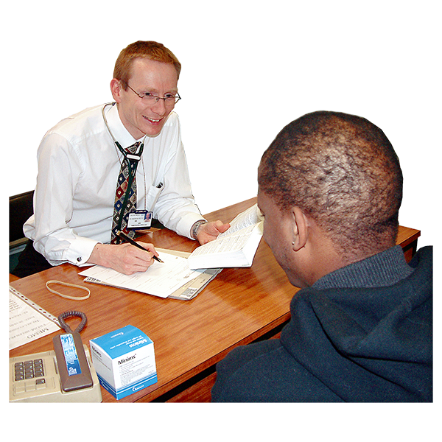

Sometimes people want to talk about their cancer. This is called a **cancer support discussion**.

You can make an appointment with a nurse or a doctor for this by calling the surgery.



You can also have an appointment with a **social prescriber.**

**Social prescribers** can help you with what matters to you, like:

* your **feelings** about cancer
* **money** worries
* finding any **extra help** you might need



You will be looked after by doctors and nurses at the hospital.

But if you want to come to the GP surgery, you can **make an appointment** at any time.



After you finish your treatment at the hospital, we will invite you for a **Cancer Care Review** at the GP surgery.

This is a meeting to talk about what matters to you and what help you need to stay well after cancer.

Remember, you can **talk to us** about anything you are worried about. Please **call the GP surgery** to make an appointment.

Yours sincerely,

Usual GP

**Other people who can help you**

Here is a link to a **website** with help for people with cancer that you might find helpful:

<https://www.macmillan.org.uk/cancer-information-and-support/get-help/translations-and-other-formats/easy-read-cancer-information>





You can also speak to someone on the **Macmillan helpline** between 8am and 8pm:

The phone number is **0808 808 00 00**



If you struggle to hear or speak, you can make **text relay calls** by dialling **18001** followed by 0808 808 0000.