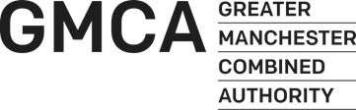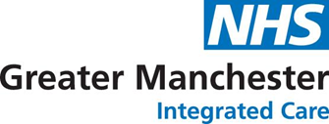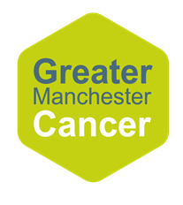

**Stakeholder Briefing:**

Greater Manchester Live Well with Cancer Programme

**January 2023**

**Background**

In May 2021 Mayor Andy Burnham pledged in his manifesto to expand the Live Well offer and create a *holistic, specific “Live Well with Cancer”* programme in Greater Manchester*.*

Everyone deserves high quality care that addresses their wider health and wellbeing needs as a result of having cancer. But currently there is no consistent Greater Manchester-wide way for someone newly diagnosed to find out about support available and no systematic way for their needs to be assessed.

In response to the manifesto commitment, Greater Manchester Cancer, Greater Manchester Integrated Care, Greater Manchester Combined Authority and Macmillan Cancer Support, have come together to create a programme that can connect the huge amount of work already taking place, or in development, in Greater Manchester to provide holistic support for people living with cancer.

**What is the Greater Manchester Live Well with Cancer Programme?**

**The Greater Manchester Live Well with Cancer Programme is looking at how we can develop a systematic person-centred response to the varied needs of people living with cancer in Greater Manchester.** This is about joining up the different forms of personalised care and support that is already available to ensure an integrated response across the system.

We know there has already been a huge amount of money, time and passion invested in person-centred care and support across health, community and neighbourhood settings. This programme will not be developing a new service sitting on top of, or unconnected to, the range of other service offers for people with cancer in Greater Manchester. Instead, the programme will be about how we can knit those services together around people affected by cancer. It will be about amplifying the great things already available, identifying where there may be gaps, and shaping this understanding into a clear offer for people living with cancer in Greater Manchester.

**This programme will weave together all the elements of support for people living with cancer from different parts of the system in Greater Manchester, via the three pillars of our health and care footprint:**

1. Personalised cancer care

Personalised cancer care means providing people with access to care and support that meets their individual needs – from the moment they receive their cancer diagnosis – so that they can live as full, healthy and active a life as possible.

1. Broader person and community centred approaches

Person and community-centred approaches recognise that people live their lives with experiences and connections that are much more than their cancer diagnosis. In Greater Manchester we are working alongside communities to bring together assets within communities, encourage equity and social connectedness and increase people’s control over their health and lives.

1. Neighbourhood models

Public services and VCSE partners are increasingly organising themselves at a neighbourhood level (30-50,000 population) which makes it easier to connect people and families to other sources of advice and support from public and voluntary services in their community.

This programme will seek to develop a sustainable and consistent offer for Greater Manchester. While a cancer diagnosis will be the qualifying factor for this programme, the intention is for the programme to act as a blueprint for extending and embedding systematic, proactive holistic support for other health conditions beyond cancer.

**What is the vision?**

We believe that all people with cancer in Greater Manchester should be able to live well and have access to a personalised care offer, so that they can be supported to make best use of all sources of support available across the system.

We want co-production in and through all that we do — from defining the problem, to shaping the solution. Our work will start with the rich assets already in our neighbourhoods, and will weave together a strategic, sustainable, clear and consistent offer across Greater Manchester.

**What could this look like to someone with cancer?**

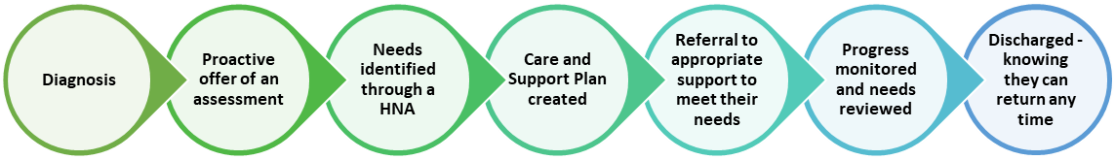

1. Rather than relying solely on other parts of the system to refer people, a proactive offer of an assessment would be made to everyone newly diagnosed with cancer in Greater Manchester.
2. Through the use of a Holistic Needs Assessment (HNA), the person’s needs would be identified, and a care and support plan generated to meet the needs identified.
3. Local community assets would be identified, and the person with cancer would be referred on or signposted to support that meets their needs.
4. The person with cancer’s progress would be monitored and reviewed, allowing them to be referred for further support if needed.
5. Once the person with cancer felt comfortable their needs had been met, they would be discharged, knowing they could return any time.

The pro-active nature of this offer would ensure intervention could take place before people reach crisis point, putting a package of support in place that will not only benefit the person living with cancer by preventing their situations from escalating, but will also relieve pressure on other parts of the system that may not have enough capacity to deliver the level of holistic personalised care they would like to.