Greater Manchester Chronic Oedema/Lymphoedema Standards

These Standards have been produced through the Greater Manchester Cancer’s Macmillan GM Lymphoedema Programme.

These standards look at the risk and management of lymphoedema/chronic oedema regardless of its cause including primary, secondary (non-cancer), secondary (cancer related lymphoedema)

These standards have been developed based on

The National Lymphoedema Partnership Commissioning Guidance

Commissioning Guidance for Lymphoedema Services for Adults Living with and Beyond Cancer
Version 2: March 2020 https://www.healthylondon.org/resource/commissioning-guidance-lymphoedema/

The BLS National Tariff Guidelines

Lymphoedema Service Specifications and Operational policies from lymphoedema services across Greater Manchester.

GM Macmillan Lymphoedema Programme
GM Macmillan Lymphoedema Programme

Revision History

Revision Date: | Version: | Changes:
18th May 2020 | Draft | Working document
14th July 2020 | Draft | Lymphoedema practitioners working group amendments
6th August 2020 | Draft | Further amendments from lymphoedema practitioners recommendations
28th August 2020 | V1 | Final amendments from review process

GM Macmillan Lymphoedema Programme

There are opportunities to make long-term financial gains through effective treatment and management of lymphoedema. There are cost efficiencies accurate prescribing of garments, reductions in cases of cellulitis resulting in decreased numbers of hospital admissions, reduced length of stay and decreased primary/community healthcare visits.

Population Needs
“Lymphoedema is chronic swelling due to failure or incompetence of the lymphatic system. It most commonly affects the lower or upper limbs, but may also affect other areas including the head and neck, trunk, breast or genitalia. Chronic oedema is often used interchangeably with the term ‘Lymphoedema’. Whilst chronic oedema may result from different pathologies it is important to note that ALL chronic oedema is in part a failure of the lymphatic drainage. The condition affects individuals of any age, gender or ethnicity.

Insufficiencies in the lymphatic system may be due to a congenital lymphatic abnormality (primary lymphoedema) or damage caused by cancer treatment, disease, infection, trauma, chronic venous insufficiency and other pathologies (secondary lymphoedema).”
National Lymphoedema Partnership (NLP) Commissioning Guidance for Lymphoedema Service for Adults in the United Kingdom – March 2019

As there is no cure for lymphoedema, continuing support and treatment from skilled healthcare professionals is necessary in order to manage the condition. Consequently, early identification of lymphoedema with appropriate advice and interventions can prevent the longer-term development of serious physical, psychological and social problems, thereby reducing the incidence of hospitalisation. Lymphoedema is classified as a long-term condition.

Greater Manchester
Below is a table showing the potential prevalence in Greater Manchester detailed within the British Lymphology Society’s Calculator.
Clinical Commissioning Group | Mid-2017 Population Estimates for Clinical Commissioning Groups (CCGs) |  | Prevalence based on Derby's 3.93 per 1000 Population |  | Prevalence based on Wales’s 6.4 per 1000 Population |  | Locality recorded prevalence (Primary Care data)
GREATER MANCHESTER | 2,832,133 |  | 11,130 |  | 18,126
NHS Bolton CCG | 284,813 |  | 1,119 |  | 1,823 |  | 403
NHS Bury CCG | 189,628 |  | 745 |  | 1,214 |  | 430
NHS HMR CCG | 218,459 |  | 859 |  | 1,398 |  | 477
NHS Manchester CCG | 545,501 |  | 2,144 |  | 3,491 |  | 910
NHS Oldham CCG | 233,759 |  | 919 |  | 1,496 |  | 563  (200 – lymph clinic)
NHS Salford CCG | 251,332 |  | 988 |  | 1,609 |  | 467
NHS Stockport CCG | 291,045 |  | 1,144 |  | 1,863 |  | 698
NHS Tameside and Glossop CCG | 257,453 |  | 1,012 |  | 1,648 |  | 1087  (298 – lymph clinic)
NHS Trafford CCG | 235,493 |  | 925 |  | 1,507 |  | TBC
NHS Wigan Borough CCG | 324,650 |  | 1,276 |  | 2,078 |  | TBC
Note:
Derby 3.93 per 1,000 population
A 2016 Study in Derby identified that there was an average 3.93 per 1000 population rising to 28.75 per 1,000 over 85.

Wales 6.4 per 1,000 population.
Lymphoedema Network Wales demonstrated an increase in prevalence from 2.6 to 6.4 per 1,000 of the population over the past six years with both incidence and prevalence rising on an annual basis

Increased Prevalence by Age
Lymphoedema Support Network offers data detailing the prevalence by age. Below is a table evidencing the increase.

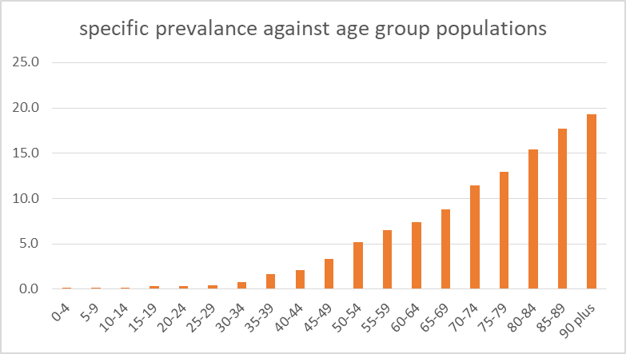

Increase in cancer related lymphoedema
Predicted increases in the prevalence of cancer-related lymphoedema are linked to the increases in cancer survivors, the aging population and rising levels of obesity.

Staging/Severity
Lymphoedema/chronic oedema is staged according to the International Society of Lymphology staging from 0 to lll, with 0 being a sub-clinical state and lll being hard fibrotic tissues with skin changes, increased folds and overgrowths. The earlier the condition is treated the less likely it is to deteriorate to stage lll.

- ISL Stage 0: A subclinical state where swelling is not evident despite impaired lymph transport. This stage may exist for months or years before oedema becomes evident.
- ISL Stage I: This represents early onset of the condition where there is accumulation of tissue fluid that subsides with limb elevation. The oedema may be pitting at this stage.
- ISL Stage II: Limb elevation alone rarely reduces swelling and pitting is manifest. ISL Late Stage II: There may or may not be pitting as tissue fibrosis is more evident.
- ISL Stage III: The tissue is hard (fibrotic) and pitting is absent. Skin changes such as thickening, hyperpigmentation, increased skin folds, fat deposits and warty overgrowths develop.

The British Lymphology Society recognises 4 population groups:
1, People at risk, 2, People with mild uncomplicated oedema, 3, People with moderate to severe OR complicated oedema regardless of severity and 4, People with oedema and advanced malignancy.

National Strategy
The management of lymphoedema should be aligned with personalised care in cancer and long-term conditions. Below are key links between lymphoedema and the national strategy:

https://www.england.nhs.uk/ourwork/clinical-policy/ltc/house-of-care/
NHS England:

The Five Year Forward View (FYFV) published by NHS England and its partners sets out the vision for the future of the NHS. It notes that ‘long term conditions are now a central task of the NHS; caring for these needs requires a partnership with patients over the longer term rather than providing single, unconnected “episodes” of care.’

This is particularly important in supporting the increasing numbers of people with more than one long term condition, more commonly known as multimorbidity; people living with frailty, and those in the last 12 months of their life – helping people with long term conditions to live well, age well and die well

NHS England – Our Declaration: person centred care for long term condition
https://www.england.nhs.uk/wp-content/uploads/2015/09/ltc-our-declaration.pdf

The 15 million people in England with long term conditions have the greatest healthcare needs of the population (50% of all GP appointments and 70% of all bed days) and their treatment and care absorbs 70% of acute and primary care budgets in England.
It is clear that current models of dealing with long term conditions are not sustainable. Rather than people having a single condition, multimorbidity is becoming the norm.

The House of Care has been created out of a need to change the way we deal with long term conditions (LTCs).
The House of Care approach provides such a model.
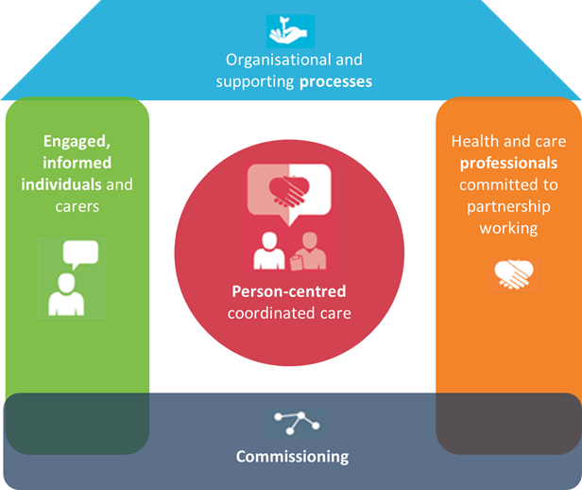

The NHS Long Term Plan
Chapter 1: A new service model for the 21st century

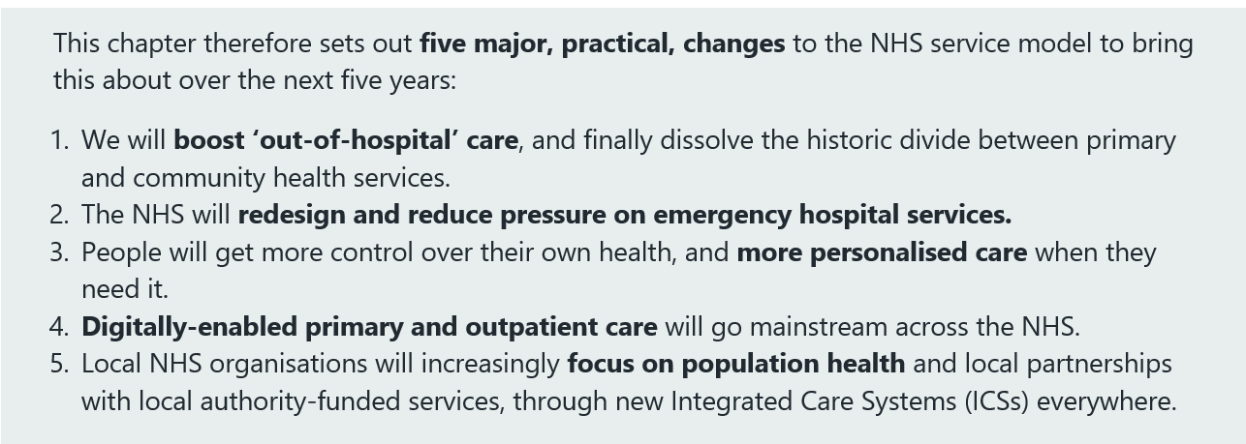

NHS England Personalised Care
The care of lymphoedema should be aligned with other work in personalised care in cancer and long-term conditions - https://www.england.nhs.uk/personalisedcare/
The Operational Model - https://www.england.nhs.uk/wp-content/uploads/2018/10/personalised-care-operating-model-1.pdf

NHS England Commissioning Guidance for Rehabilitation raises management of chronic condition and lymphoedema should be considered within below model of rehabilitation.
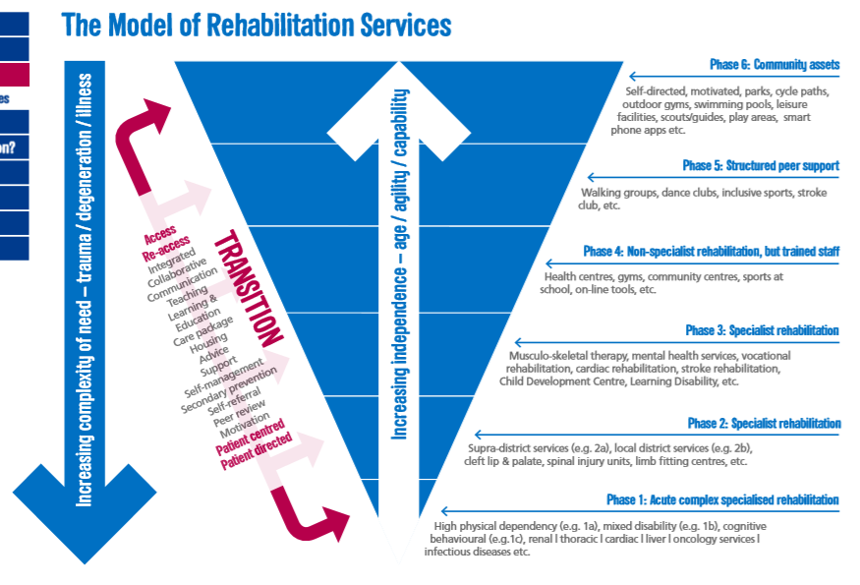
https://www.england.nhs.uk/wp-content/uploads/2016/04/rehabilitation-comms-guid-16-17.pdf

NHS Outcome Framework
https://digital.nhs.uk/data-and-information/publications/statistical/nhs-outcomes-framework
Domain 2 | Enhancing quality of life for people with long-term conditions  2.Health-related quality of life for people with long-term conditions  2.1 Proportion of people feeling supported to manage their condition  2.2 Employment of people with long-term conditions  2.4 Health-related quality of life for carers
Domain 3 | Helping people to recover from episodes of ill-health or following injury  3a Emergency admissions for acute conditions that should not usually require hospital admission
Domain 4 | Ensuring people have a positive experience of care  4.1 Patient experience of outpatient services  4a.i Patient experience of GP services  4c Friends and family test  4.1 Patient experience of outpatient services
Domain 5 | Treating and caring for people in safe environment and protecting them from avoidable harm

A Five Year Framework for GPs
Below are extracts of improvements that Primary Care are nationally focussing on and can be linked to the provision of lymphoedema:

  - General practice will deliver specific improvements, such as better support for care homes
6.5 The seven are focused on areas where Primary Care Networks can have significant impact against the ‘triple aim’:
- improving the quality of care for people with multiple morbidities (for example through holistic and personalised care and support planning, structured medication reviews, and more intensive support for patients who need it most including care home residents);
- and helping to make the NHS more sustainable (for example, by helping to reduce avoidable hospital admissions).
  - The seven national service specifications are:
- Structured Medications Review and Optimisation;
Linked to (iii) frail elderly; (iv) care home residents; and (v) patients with complex needs, taking large numbers of different medications. We will expect a particular focus on tackling inequalities.
- Enhanced Health in Care Homes, to implement the vanguard model;
will ensure that all care homes are supported by a consistent team of multi-disciplinary healthcare professionals delivering proactive and reactive care, led by named GPs and nurse practitioners, organised by the Primary Care Network
- Anticipatory Care requirements for high need patients typically experiencing several long term conditions, joint with community services;
- Personalised Care, to implement the NHS Comprehensive Model;

International Lymphoedema Framework Standards of Practice:

Standard 1: Identification of people at risk of or with lymphoedema
Standard 2: Empowerment of people at risk of or with lymphoedema
Standard 3: Provision of lymphoedema services that deliver high quality clinical care that is subject to continuous improvement and integrates community, hospital and hospice based services
Standard 4: Provision of high quality clinical care for people with cellulitis/erysipelas
Standard 5: Provision of compression garments for people with lymphoedema
Standard 6: Provision of multi-agency health and social care

Greater Manchester Standards
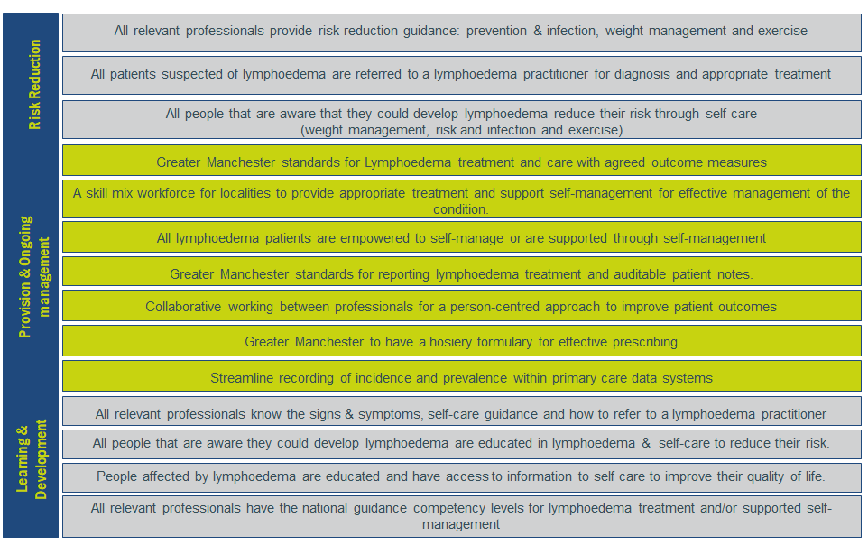
System Approach for Chronic Oedema/Lymphoedema
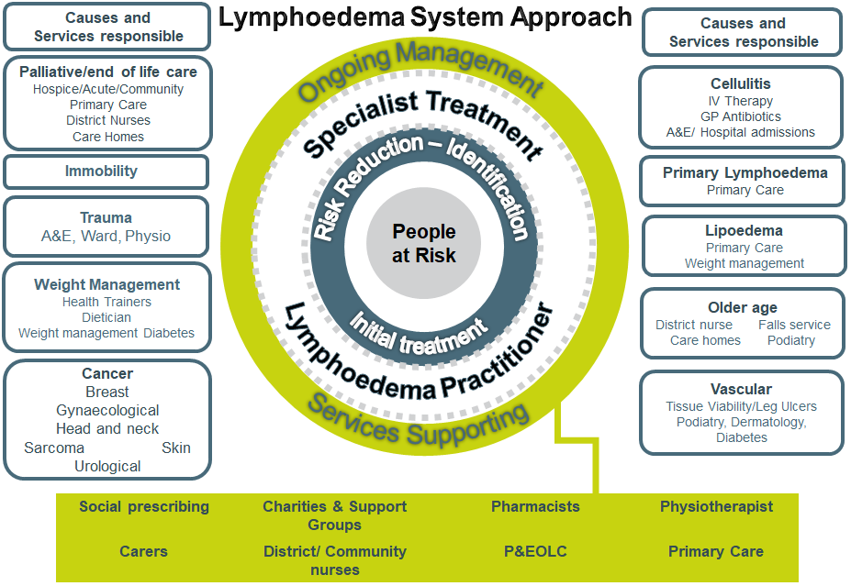

Greater Manchester Local Outcomes:

- Greater Manchester localities will have a known understanding of lymphoedema incidence and prevalence

Risk Reduction:

- People at risk of lymphoedema will be identified earlier reducing possible physical, psychological and social consequences
  - No. of professionals trained in signs/symptoms and risk reduction guidance
    - Baseline to be agreed
  - Reduction in complex cases/evidencing improvement goals in severity of condition
    - Baseline against current severity reviewed yearly

Treatment and Ongoing Management

- Empower and aid patients to self-manage their condition as much as possible, preventing deterioration, maximising/maintaining functionality and relieving discomfort.
  - 95% of patients receive a written care plan for supported self-management
  - Xx% of patients have a draft treatment plan in alignment with the BLS Tariff Guidelines
    - Baseline to be agreed
- Patients are referred to appropriate services to support patient’s person centred care

- Appropriate treatment and management will assist in reducing the incidence of hospitalisation and the use of IV antibiotics by lessening the risk of cellulitis and other tissue viability problems.
  - Xx% evidence concordance of garments (baseline to be agreed)
  - Xx% Reduction in IV Therapy for cellulitis (baseline to be agreed)
  - Reduction or increased timeframe of episodes of infections

- Effectiveness of interventions and should include (as a minimum), measures for both quality of life and reduction and control of limb volumes. Examples of tools that could be used:
  - LymQoL upper limb31
  - LymQoL lower limb32
  - EQ-5D-L (N.B. registration is required)
    - Improved physical impact (reduced swelling)
    - Improved psychological impact
    - Improved social-economic impact

In order to address the lack of guidance on what services should measure as outcomes, the International Lymphoedema Framework embarked on a project to address this called the ILF- Com. This is still taking place with a number of countries that have taken part in interviews and a survey completed in 2019 with over 8,000 respondents worldwide. https://www.lympho.org/chronic-oedema-outcome-measure-ilf-com/

Learning and Development

- Improve the levels of knowledge of the wider workforce around lymphoedema management
- 20% of lymphoedema provision is for training, education and awareness raising
- Xx no of Primary Care have training
- XX no of wider professionals
- Patient expert programme.

KPIs
Outcome, metric, expected change | Baseline | Target | Rationale | Timeline | Source / method of measurement and reporting
% of patients contacted within 5 working days of referral | No current baseline | 95% | To ensure prompt assess and treatment of people with lymphoedema | Outset
Waiting time in working days for a routine appointment | 6 weeks  (30 days) | 90% | Early identification of symptomatic lymphoedema and timely referral allows for earlier effective intervention based upon need. | Outset
Waiting time in working days for an urgent appointment | 10 working days | 90% | Early identification of symptomatic lymphoedema and timely referral allows for earlier effective intervention based upon need. | Outset
Waiting time in working days for a Palliative/End of Life | 5 working days | 90% | Early identification of symptomatic lymphoedema and timely referral allows for earlier effective intervention based upon need. | Outset
A letter of diagnosis sent to GP |  | 100% | To provide accurate recording of prevalence in primary care | Outset
Discharge summary back to GP | No current baseline | 95% | To ensure prompt on-going and appropriate management / treatment of people with lymphoedema | Outset

Delivery

Risk Reduction
These standards are to ensure people at risk of lymphoedema will be identified earlier, reducing possible physical, psychological and social consequences of neglect. A pro-active approach to identify cases early and provide rapid access to treatment, empowering patients to self-manage and prevent worsening symptoms would be more cost effective than managing an increasing number of severe and complex cases

Risk Factors:
Age | more common with increasing age.
Obesity | Increased abdominal girth causes pressure on the lymphatic vessels in the groin, reducing lymphatic and venous return.
Cancer | Levels of lymphoedema post cancer treatment vary according to the site and treatment
Cellulitis | if a patient has had more than one episode of cellulitis in a limb, there is almost certainly some failure of lymphatic drainage. (66% of the recorded uk cases in 2013/14 were hospitalised)
Trauma | may affect the mechanics of the lymphatic system, including, but not exclusively, burns, orthopaedic trauma or surgery, abdominal surgery and long-standing skin disorders.
Damaged venous system | Varicose veins, Deep Vein Thrombosis, varicose vein stripping and chronic venous insufficiency can all cause a reduction in the normal transit capacity of the lymphatic system
Immobility | Any reduction in the ability of the muscles to contract normally may mean the venous and lymphatic systems lack the impetus to drain as effectively and a dependent or gravitational chronic oedema/lymphoedema may result. Such may include Cerebral Vascular Accident, Multiple Sclerosis, Motor Neurone Disease and arthritis.

Patients at risk of developing lymphoedema should receive advice from a health care professional. (These Health Care professionals need to have the adequate training for this). This should include:
  - signs & symptoms,
  - provide advice and guidance on how to reduce the risk (Skin Care, Weight Management and Healthy Lifestyle)
  - share details of where to get additional information (Macmillan Leaflets and Information and Support Centres, Lymphoedema Support Network, British Lymphology Society.

Primary Care
Patients identified at risk of developing lymphoedema (where appropriate) must be informed and given written and verbal information on how to minimise their risk.
- Practice Nurses to discuss risk reduction advice for those they see due weight management, diabetes, poorly managed venous disease and lipoedema patients.
- Practice Nurses to prescribe a Class 1 British standard compression to reduce the development of chronic oedema in alignment to the Best Practice Statement Holistic Management of Venous Leg Ulceration
- GPs to follow cellulitis NICE Guidelines on recurring cellulitis.
Including:
  - If a person has recurrent episodes of cellulitis (more than two episodes at the same site within one year), consider routine referral to secondary care for advice on the use of prophylactic antibiotics.
- Provide appropriate compression garments
- Refer to lymphoedema practitioner if appropriate

Cancer services
“25% of people with cancer face poor health or disability after treatment, 70% are also living with at least one other long-term condition and nationally it is estimated that 70,000 people are living with cancer and three or more long-term conditions. It is clear that as the cancer story is changing, we need to radically rethink how we deliver care to our populations.”
https://www.healthylondon.org/wp-content/uploads/2020/03/Lymphoedema-Commissioning-Guidance-2020.pdf

Good quality advice and information throughout the cancer pathway can help to prevent swelling, reduce complexity and assist patients to self-manage. An example of this is the provision of written and verbal information pre-operatively to patients awaiting lymph node removal surgery for breast or ovarian cancer, to make them aware of the risks of lymphoedema, what to look for and risk reduction strategies.

The below will support the Personalised Care Model and NHS Long Term Plan

- Include lymphoedema management in Trust’s Cancer MDT Operational Policies.
- Cancer Holistic Needs Assessments state swelling as a concern. The care plan will address guidance on how to support reducing the risk of swelling/Chronic oedema
- Health and Well-being events offer stalls/talks.
  - Lymphoedema practitioners to link with Lead Cancer Nurses to understand local need.
  - A sustainable option use films to reduce the risk
- The relevant end of treatment summaries will include the risk of lymphoedema as a consequence for cancer
- Cancer Care Reviews (GPs)
- Gateway C late effects module will include the risk of lymphoedema to support Primary Care to support patients who have concerns about lymphoedema as a late effect.

Cellulitis
- Ensure information is accessible to A&E, Ward staff, IV Therapy Home services/HIIT on accessing lymphoedema provision
- Lymphoedema workforce to collaboratively work with their locality A&E department and IV Home Therapy service
- GPs to following NICE guidelines for recurring cellulitis

Palliative Care
- The International Lymphoedema Framework position document on the The management of lymphoedema in advanced cancer and oedema at the end of life published document:
https://www.lympho.org/wp-content/uploads/2016/03/Palliative-Document.pdf

Weight Management
- Patients identified at risk of developing lymphoedema must be informed and given written and verbal information on how to minimise their risk.
  - Primary Care GPs, Practice Nurses and Health Improvement Practitioners
  - Bariatric surgery
  - Tiered 3 weight management services
  - Tier 2 weight management
  - Integrated lifestyle services

Ageing
- Care Home staff to be trained to support the management of reducing the risk of lymphoedema supporting good skin care management and mobility,
- Care workers going into older people homes to support good skin care management,
- District nurses and other community nurses to recognise signs and symptoms and refer to lymphoedema practitioner, if required.

Vascular
- Nurses specialising in wound care to be trained in lymphoedema care
- Leg ulcers nurses to work with lymphoedema practitioner
- Consultants to know how to access lymphoedema practitioners
- Consultants to accept lymphoscintigraphy referrals

Treatment and Ongoing Management
Ideal Model:

An ideal model would be structured to deliver against the set of standards, in line with the management of chronic disease and its prevention, through an integrated care pathway approach. The framework would enable training of the wider healthcare force, enabling co-ordination of care and capacity for treating ageing and obese patients who are housebound; also, treatment for patients in hospices and in the terminal stages of life.

- A Clinical Lead/Manage to co-ordinate service but direct contact with commissioner to enhance relationships in how service/services are delivering against a specification.
- Clinical staff levels and a skill mix of workforce that is trained appropriately and addresses local need (national recommendations of 220 - 250 patients per 1 WTE qualified lymphoedema practitioner).
- Administration to support clinical staff and oversee quality assurance.
- Palliative care teams should include staff that are competent to manage palliative lymphoedema. Domiciliary care may be required via the palliative care specialist.
- Embed the referral pathway across the locality and/or system
- Education programme to train wider healthcare to support in care homes, homes and hospices
- A collaborative approach to work with other specialist services (cancer CNSs, tissue viability, weight management, health trainers, podiatrist, dermatologists, district nurses, care workers etc)
- An agreed discharge process for cancer only lymphoedema services to refer to community services/primary care to manage as part of long term conditions
- A discharge process for community services to discharge back to primary care
- Primary Care staff to manage “At risk” and mild Lymphoedema. When patients have reached a stable condition. GPs, or other staff, may provide treatment reviews (this may include a vascular review) and compression garments provision.
- Direct re-access to lymphoedema practitioners should patient require further specialist management.
- A cost effective system for compression garments.

The highest quality treatment, advisory and support service will be provided to patients with chronic oedema/lymphoedema in order to prepare the patient for long-term independence and to improve the quality of life for palliative lymphoedema patients. This will assist in helping patients to self-manage their condition as much as possible, which will:
- Prevent deterioration
- Maximise/maintain functionality
- Relieve discomfort
- Provide sufficient knowledge and information to enable them to make informed decisions.

The overall objective of treatment is to achieve maximum improvement that empowers sufferers with the necessary skills to self-manage. Aims include:
- Reduction and long term control of the oedema (volume and shape)
- Prevention of infection (cellulitis) - avoidance of, Antibiotics, IV Therapy and hospital admission.
- Prevention of lymph leakage (lymphorrhoea) and other skin tissue changes e.g. hyperkeratosis
- Improvement and maintenance of function and mobility of the affected, swollen area
- Resolution of symptoms such as pain, heaviness and ache
- Education and empowerment of patients to self-manage their care
- Support and reduce psychological distress
- Enhancement in quality of life
- Improved Health and well-being
Management of Lymphoedema
Lymphoedema Practitioners to follow the Internal consensus - Best Practice for the Management of Lymphoedema
https://www.lympho.org/portfolio/best-practice-for-the-management-of-lymphoedema/

Referrals:
Healthcare professionals including GPs, Consultants, Clinical Nurse Specialists, AHPs or other qualified professionals. Consideration should also be given to self-referral where possible.

Waiting times for initial assessment or first treatment?
Palliative – 5 working days
Urgent – 10 working days
Routine – 30 working days (6 weeks)

Before referring rule out
- Recurrence of malignancy
- Deep Venous Thrombosis (DVT)
- Cardiac failure and renal failure

Referral Criteria
- Lipoedema
- Suspected primary lymphoedema
- Suspected secondary lymphoedema
- Chronic oedema in the limb/body part of >3 months and has one or more of the following:
  - Swelling
  - Heaviness
  - Pain or tension
  - Tightness and fullness
- Unknown cause of swelling.
- Unexplained oedema in those <35 years
- Sudden increase in swelling or pain.
- Recurrent cellulitis
- Hosiery fitting problems
- When obesity complicated the management of the condition
- Venous Ulcer patients with Lymphoedema. (Joint care with venuous leg ulcer
- Suspected secondary cancer – cancer related
  - Long term complications due to radiotherapy or surgery.

Urgent referral
- Midline oedema (head, neck, trunk or genitalia).
- Skin problems such as severe papilomatosis, hyperkeratosis, etc.
- Severe foot distortion/bulbous
- Lymphorrhea
- Palliative Care

Contact lymphoedema practitioner for guidance on referral for:
- Patients with post-operative swelling within 8 weeks of surgery

Exclusions:
- Untreated, recently diagnosed Deep Vein Thrombosis (DVT) (following vascular assessment)
- Patients with unstable cardiac/renal failure

Triage
All lymphoedema referrals will be triaged at the point of entry by a lymphoedema practitioner (band 6 or above). The triage will categorise referrals into the following areas with Tier 1 being managed in primary care (no referral required).
- Tier 1 (patients at risk of developing lymphoedema/ILF Stage 0) would be provided by health and social care professionals– generally covering basic awareness and prevention of infection in lymphoedema. These cases would generally not be referred to the lymphoedema practitioners.
- Tier 2 (BLS mild/ILF Stage l) Assessment and first appointment to be completed by lymphoedema practitioner. Treatment and ongoing management to be completed by wider healthcare workforce who have relevant competencies or with lymphoedema practitioner depending on patient’s needs
- Tier 3 (moderate – Severe/ILF Stage ll – Stage lll) would be provided by appropriate practitioners with access to both medical and diagnostic support services.

Appointment slots for patients.
The British Lymphoedema Society advises within the Tariff Guidelines of the following:
- First assessment 60 minutes for all patients (bi-literal additional time required)
- All treatment in blocks of 40 minutes per oedema site for all patients

NB: Timeframes to be adapted for exceptional circumstances such as communication barriers, mental health and physical disability and learning disabilities.

Initial Assessment
A holistic assessment to be completed to identify severity of condition and patient’s needs. Complete the LymQOL tool or other assessment tool to set a baseline of volume, severity of condition, pain, mobility, dexterity, function and quality of life. Identify wider healthcare needs and possible discussions of being referred to weight management, dietician, leg ulcer clinic, physiotherapists, OT, Podiatry.

Lymphoedema practitioner to have an assigned vascular consultant to discuss any concerns. If the vascular assessment causes concern complete a Doppler test or use BLS guidance
Practitioners to work with patient to set realistic goals for each patient and empower them with knowledge and skills to self-manage writing and sharing a treatment care plan including level of treatment based on the British Lymphoedema Society Tariff guidelines for year 1, as detailed in the below table. A letter sent to GP with diagnosis and planned treatment.

Treatment - Lymphoedema interventions / package of care may include:

Decongestive lymphatic therapy (DLT). There are four components to DLT:
- Compression bandages and garments – to move fluid out of the affected limb and minimise further build-up
- Skin care – to keep the skin in good condition and reduce the chances of infection
- Exercises – to use muscles in the affected limb to improve lymph drainage
- Specialised massage techniques – known as manual lymphatic drainage (MLD) – to stimulate the flow of fluid in the lymphatic system and reduce swelling

Individuals may require other bespoke methods of treatment to include:-
- Kinesio tape
- Intermittent sequential compression therapy
- Low level light laser therapy
- Lympho touch
- Deep Oscillation Therapy (DOT)

Surgical approaches: There are 3 surgical approaches; lymphatic venous anastomosis (LVA), liposuction and lymph node transfer. This is a developing area and not widely available on the NHS.

Treatment –
Group | Description | Interventions required | Who is responsible
At risk/ILF stage 0 | No swelling present | Information about lymphoedema provided in a clear and concise way to support the patients needs.  Preventative advice and information needs.  Management of obesity  Management of Skin Care | Surgeons  Cancer CNS & AHPs  GPs & PNs  Weight management  Palliative & EoL  workforce linked to cellulitis  workforce linked to Older people  workforce linked to vascular
Mild swelling/ ILF stage 1. | Less than 20% excess volume with no or little skin changes | - Referral to lymphoedema service for full assessment  - Treatment to include 4 cornerstones of care including compression garments  Plus information needs for self-care  - Referral onto other specialist services including dermatology, cardiology, vascular and weight management and psychological services.  - Carer may require specialist teaching to support self-management  - Community teams (if competent) to provide supported care and follow ups once discharged | Lymphoedema key worker or specialist practitioner prior to discharge to community services/primary care for ongoing management reviews
Moderate swelling/ ILF stage 2 (early and late). | 20-40% excess volume with mild skin and soft tissue changes | - Referral to lymphoedema service for full assessment  - Treatment to include 4 cornerstones of care  Plus information needs for self-care  - Compression to include off the shelf, made to measure  garments/specialist garments in alignment with guidelines  - Decongestive lymphatic therapy may be  required plus other bespoke treatment modalities if the limb is misshapen, there are secondary skin changes or recurrent episodes of cellulitis  - Regular follow up in alignment with the recommended treatment times below and consideration of patient and if they have co-morbidities.  Possible referral back into community services if improvement puts them back into the mild group.  - Yearly follow ups until stable  - Referral onto other specialist services including dermatology, cardiology, vascular, weight management and psychological services.  - Carer may require specialist teaching to support self-management  - Community teams (if competent) to provide supported care and follow ups once discharged | Lymphoedema specialist practitioner or lymphoedema key worker under supervision
Severe swelling / ILF stage 3 | More than 40% excess volume` | - Referral to lymphoedema service for full assessment  - Treatment to include 4 cornerstones of care  Plus information needs for self-care  - Compression to include off the shelf, made to measure garments/specialist garments in alignment with guidelines  - Decongestive lymphatic therapy will be required plus other bespoke treatment modalities, multiple courses of treatment may be required.  - Regular follow up in alignment with the recommended treatment times below and consideration of patient and if they have co-morbidities.  - Referral onto other specialist services including dermatology, cardiology, vascular and weight management and psychological services.  - Carer may require specialist teaching to support self-management  - Community teams (if competent) to provide supported care and follow ups once discharged | Lymphoedema Specialist practitioner
Genital Swelling | Swelling anywhere in the male or female genitalia +/- leg swelling | - Referral to lymphoedema service for full assessment  - Treatment to include skin care, self-massage, compression shorts /tights, kinesio taping and pneumatic compression pump.  - Will require a course of treatment. On discharge will need to be able to self-refer back into lymphoedema service in a timely manner. | Lymphoedema Specialist Practitioner.
Breast Swelling | Swelling in the breast or the chest wall/trunk on the affected side+/- arm swelling | - Referral to lymphoedema service for full assessment  - Treatment to include skin care, self-massage, manual lymphatic drainage, kinesio tape or other bespoke treatment  - Advice on bra fitting  - Provision of compression bra/vests  - Scar and soft tissue management.  - Shoulder exercises  - Will require a course of treatment. On discharge will need to be able to self-refer back into lymphoedema service in a timely manner | Lymphoedema Specialist Practitioner and specialist breast physiotherapist
Head and Neck Swelling | Swelling of the face/neck or submental region | - Referral to lymphoedema service for full assessment  - Treatment to include skin care, self-massage, manual lymph drainage, kinesio tape or other bespoke treatments  - Facial /shoulder and neck exercises  - Possible measurement for neck strap  - Scar and soft tissue management.  - Will require a course of treatment. On discharge will need to be able to self-refer back into lymphoedema service in a timely manner | Lymphoedema Specialist Practitioner  and specialist head and neck physiotherapist
Advanced cancer and at End of Life | Extensive disease, fungating wounds, lymphorrhea, nerve damage. | - Referral to lymphoedema service for full assessment  - Treatment to include skin care and possibly to be measured for made to measure garments or wraps.  - May require palliative bandaging to stop lymphorrhea  - May require referring to other specialist services such as tissue viability, pain management or psychological services. | Lymphoedema Specialist Practitioner

The summary below shows the recommended treatment times in alignment to the BLS’s tariff guidelines:
Simple/Mild (ILF Stagel) |  |  |  | Moderate (ILF Stage ll)
Year 1 | Direct clinical time  (Clinic Slot Required) | Indirect Time  (Paperwork, Clinical Governance, training) |  | Year 1 | Direct clinical time  (Clinic Slot Required) | Indirect Time  (Paperwork, Clinical Governance, training)
First Assessment | 60 minutes | 30 mins |  | First Assessment | 60 minutes | 30 mins
Tx schedule | 40 minutes | 20 mins |  | Tx schedule  First tx  DLT per oedema site | 40 minutes  40 minutes x 20 | 20 mins  20 minutes x 20
3 Follow up | 40 minutes x 3 | 20 minutes x 3 |  | 3 x Follow up | 40 minutes x 3 | 20 minutes x 3
Total Time | 220 minutes or  3 hours 40 minutes | 140 minutes or  2 hours, 20 minutes |  | Total time | 1020 minutes or  17 hours | 540 minutes  Or  9 hours
Yearly Ongoing* |  |  |  | Yearly Ongoing*
2 Follow ups | 40 minutes x 2 | 20 minutes x 2 |  | 2 Follow ups | 40 minutes x 2 | 20 minutes x 2
Total Time | 80 minutes | 40 minutes |  | Total Time | 80 minutes | 40 minutes
*until stable for discharge/back to non- specialised service.

Complex (ILF Stage lll) |  |  |  | Very Complex (ILF Stage lll)
Year 1 | Direct clinical time  (Clinic Slot Required) | Indirect Time  (Paperwork, Clinical Governance, training) |  | Year 1 | Direct clinical time  (Clinic Slot Required) | Indirect Time  (Paperwork, Clinical Governance, training)
First Assessment | 60 minutes | 30 mins |  | First Assessment | 60 minutes | 30 mins
Tx schedule  First tx  DLT per oedema site | 40 minutes  40 minutes x 60 | 20 mins  20 minutes x 60 |  | Tx schedule  First tx  DLT per oedema site | 40 minutes  40 minutes x 200 | 20 mins  20 minutes x 200
3 Follow up | 40 minutes x 3 | 20 minutes x 3 |  | Follow up | To be negotiated
Total Time | 2,620 minutes  43 hours 40 minutes | 1,310 minutes or  21 hours 50 minutes |  | Total time | At least  8,100 minutes or 135 hours | At Least 4,050 minutes or  67 hours and 30 mins
Yearly Ongoing* |  |  |  | Yearly Ongoing*
2 Follow ups | 40 minutes x 2 | 20 minutes x 2 |  | Follow ups | To be negotiated
Total Time | 80 minutes | 40 minutes

Review of Treatment/Care plan:
All care plans are reviewed and evaluated at regular intervals. Treatment plans are evaluated as needs change.
Review dates are set within the care planning schedule and documented. In reviewing the care plan the following will be included:
- The relevance of the care plan
- The effectiveness of care plans/outcomes
- Any unmet needs
- Patient satisfaction with the care
- Discharge patients at an appropriate time

Patients are to be involved in their lymphoedema treatment planning process and mutual goals set and adhered to.

Patients with a BMI equal or greater than 40
British Lymphology Society’s Treatment pathway for Lymphoedema patients with a Body Mass Index (BMI) equal or greater than 40 kg/m²
https://www.thebls.com/public/uploads/documents/document-59171511440602.pdf

Prescribing of Garments
A Greater Manchester Standardisation of prescribing garments and developing an effective ordering system to be agreed and implemented

This will also include how lymphoedema practitioners can support primary care and pharmacist to reduce incorrect ordering of garments that potentially could deteriorate the patient’s condition.

Discharge:
Patients are discharged from the service when the following criteria are met:
- The patient is free of swelling
- When no further intervention is planned.
- The patient declines to further access the service or refuses to comply with treatment plans.
- The patient is proficient in the self-care of the oedema which is stable and uncomplicated and maintained either without compression or with compression garments available on prescription (FP10).

All patients are issued with discharge advice, details of compression garment and a contact number in case of future problems. The GP is informed by letter.

There should be a process for rapid access for re-referrals for those patients that have been discharged but need lymphoedema required further specialist intervention.

Workforce
A skill mix with all patients being triaged by a senior member of staff (band 6 or higher). Patients may require various levels of lymphoedema management and, after triaging, can be directed to the care of the most suitable grade. The care of a patient may begin with the most specialist member of staff but could then be cascaded down through the skill mix as the condition is better managed. Members of a lymphoedema specialist team can come from a variety of backgrounds including nursing, AHPs, Manual Lymphatic Drainage (MLD) therapists and others. All staff should have skills that support holistic management.

As a guide, specialist lymphoedema services could expect each 1.0WTE lymphoedema therapist to hold a caseload of 220-250 patients/year”

A full outline of lymphoedema practitioner levels of responsibility is taken from the British Lymphology Society (BLS) ‘Professional Roles in the Care of Lymphoedema’
https://www.thebls.com/public/uploads/documents/document-25011520254971.pdf

Note: The Royal Colleague of Nursing has recently developed a Breast Care Nurse Competency Framework that includes the management/treatment of lymphoedema in their clinics. (Details in Learning and Development section below)

Multi-Disciplinary Team (MDT) Working
Lymphoedema practitioners are required to build and maintain relationships to deliver a system approach to lymphoedema care. These could include:
- Attending/providing resources for Cancer Health and Well-being events
- Building relationships with Macmillan Cancer Support information centres and other cancer related support
- Attending Cancer Clinical Nurse Specialists meetings
- Representation on GM Cancer Pathway boards
- Community lymphoedema practitioners to attend Integrated Neighbourhood meetings
- Presenting at GP training hubs and Primary Care Networks
- Links with interdependent workforce for a personalised care approach:
- GPs and Primary Care Networks
- Cancer care teams including nursing, medical and AHPs
- Palliative care teams
- Primary care nursing
- Long-term conditions management teams
- Physiotherapists
- Local leg ulcer clinics
- Pharmacies
- Local authority care services
- Local hospitals
- Local hospices
- Health Trainers – appropriate exercise

Clinical space
All lymphoedema services need dedicated clinical space. Some clinics may have assessment equipment and electric plinths, which are bulky, heavy and cannot easily be moved. Bariatric equipment may also be needed. Privacy is important when dealing with patients who have lymphoedema as they will often need to get undressed and may be discussing issues of a sensitive nature. Clinical rooms are more suitable than cubicles with curtains.

Equipment:
Below a list of equipment that support the treatment of lymphoedema
- Doppler
- Low Light laser
- Bio-compression pumps
- Bariatric equipment and clinic space
- Physio touch

Data Recording/Reporting:
National community data set code 41 - Lymphoedema

The collection of the minimum dataset that has been recommended by the National Lymphoedema Partnership. This can be found:
https://www.healthylondon.org/resource/commissioning-guidance-lymphoedema/

Other data to collect that is not included are:

- Practitioner – Band level
- Initial Assessment
- How Many Oedema sites
- First Treatment
- DLT Treatment 2 – 600 (Year 1)
- Year 1 Follow UP 1 – 3
- Ongoing Follow UP 1 – 2
- Ongoing Follow UP – additional
- Other Treatment (Agreed drop down list)
- Clinic time spent
- UTA/DNA

Outcomes:
Data to collect that enables evidence for the agreed outcomes/KPIs

Service Evaluation/Clinical Auditing
NHS Improvement – Quality Service Improvement and redesign tools
https://improvement.nhs.uk/resources/quality-service-improvement-and-redesign-qsir-tools/

Primary Care:
Lymphoedema practitioners are aware of the Primary Care data coding for diagnosis of lymphoedema and treatment of lymphoedema. A letter will be sent to the GP after patient’s first appointment with diagnosis and treatment codes.

Commissioners will be able to retrieve reports to evidence the increase in prevalence, understand the local incidence rates.

Secondary Care
All NHS providers in England and Wales ensure that ICD code 189.0 is used to record in-patient and out-patient lymphoedema activity and that the appropriate ICD codes for cellulitis are used (code dependent on site of infection) and that non NHS providers capture equivalent data.

IV Home Therapy Services
Record lymphoedema related cellulitis and work collaboratively with lymphoedema practitioners

Greater Manchester Learning and Development Standards

It is recommended that the Greater Manchester lymphoedema practitioners develop a Community of Practice that has a set of terms of reference with the aim to standardise patient education and wider healthcare professional’s education.

Patient Education:

It is recommended that the Greater Manchester Lymphoedema practitioners develop a sub group to standardise patient education:

At Risk
- Lymphoedema as a consequence of cancer treatment to be included in the End of Treatment Summaries and Health and Wellbeing activity.

Post diagnosis
- Individual ongoing education. During first year of treatment to allow the patient to understand how to effectively self-manage and be discharged.

Healthcare Professionals:

Lymphoedema workforce:

Competencies
All specialist staff must undergo specialist training in line with the BLS professional roles in the Care of Lymphoedema (2016). https://www.thebls.com/public/uploads/documents/document-64791511440750.pdf

The provision of MLD to patients with lymphoedema should be performed by those with certified training from one of the following schools of MLD:

Casley Smith
FG-MLD
Foldi
Vodder

All practitioners must update their practice according to the School’s recommendations. Information about certified practitioners able to treat patients with lymphoedema is available from MLD-UK (http://www.mlduk.org.uk); BLS (https://www.thebls.com); LSN (https://www.lymphoedema.org); and Lymphoedema Training Academy (LTA) (http://www.lymph.org.uk/)

The lymphoedema practitioners to keep updated on recent research and current evidence around lymphoedema management.

Succession planning
Training wider healthcare workforce appropriately in the integrated neighbourhood teams would enhance clinical interest in specialising in this area.

Wider Healthcare workforce

At Risk Group and early intervention:
Health professionals being educated to support the at risk groups to help patients know their requirements to reduce the risk but also for early referrals, this is likely to mean the condition is not as complex and therefore less treatment required with the specialist services.

Undergraduates:
A long term approach is ensuring lymphoedema is part of undergraduate’s course contents.
The Internal Lymphoedema Framework has developed benchmark statements for undergraduate courses. Universities have requested course content - https://www.lympho.org/lebs/

Below are the benchmarks:

Benchmark 1 | Explore the anatomy and physiology of the lymphatic system
Benchmark 2 | Discuss the pathophysiology of lymphoedema
Benchmark 3 | Recognise that there are various causes of oedema which may co-exist with lymphoedema
Benchmark 4 | Identify the features of lymphoedema
Benchmark 5 | Explore the education needs of individuals who have, or at risk of developing lymphoedema and how these might be met
Benchmark 6 | Explore the basics of lymphoedema management

There is the national development of this providing expected learning outcomes, curriculum, resources and assessment.

Current workforce:
Investment in lymphoedema training will improve working relationships and earlier referrals where the severity of the condition is less severe and requires less specialist treatment and efficient discharging for self-management.

It is recommended that Greater Manchester lymphoedema work together to develop a yearly timetable of education within their locality of specialist area (Cancer). Ensure training is aligned to the outcomes within the BLS professional roles in the Care of Lymphoedema (2016). https://www.thebls.com/public/uploads/documents/document-64791511440750.pdf

Non-specialist staff must have a suitable knowledge and competency base suitable for their role. This could be provided in various ways:
- Localised small group education organised by local specialist teams which will also develop the care network and partnerships.
- Several universities have key worker level courses
- Palliative care specialist may require a full lymphoedema certification course initially but may not require as regular updates as lymphoedema specialists as care is usually modified.
- The Hosiery companies provide training
- Locality GP/Primary Care Training Hubs
- Communication to GPs to review the Gateway C late Effects film
- Online learning tools

Online Information and Training:
- British Lymphoedema Society – Information for Professionals and Patient -https://www.thebls.com/pages/professional-and-patients
- Lymphoedema Support Network has produced two eLearning modules aimed at General Practitioners in conjunction with British Medical Journal Learning and the Royal College of General Practitioners. Free and CPD points.

Competencies for community workforce:
Greater Manchester Strategic Clinical Network’s The MARS Project. MARS aims to reduce the prevalence of major limb amputation by at least one third in order to bring it in-line with the national average. This will be achieved by working across GM Transformational themes 1,2 and 3 in order to develop a ‘whole systems’ solution. The project is developing a competency framework for TV, podiatry, DN and lymphoedema and to develop a lower limb wound competency framework.

Competencies within the Cancer workforce:
Clinical Nurse Specialist to evidence the level of competencies for lymphoedema. Below is the Royal College of Nursing Breast Care Nurse’s competency framework that includes a lymphoedema section

It is recommended for Greater Manchester to work with The Christie NHS Foundation Trust School of Oncology to develop a course similar to the course delivered at the Marsden or to develop course content for the MSc Specialist Practice (Cancer)
https://www.manchester.ac.uk/study/masters/courses/list/10985/msc-specialist-practice-cancer/course-details/#course-profile

The Royal Marsden School - 15 credits of Level 6 Lymphoedema principles and practice (Validated by the University of East Anglia).
https://www.royalmarsdenschool.ac.uk/courses/modules/lymphoedema-principles-and-practice-blended-learning

Competencies in Palliative and End of Life Care:
To have representation for lymphoedema in the development of the GM Palliative & EOLC Framework. Identifying where in the delivery plan the International Lymphoedema Framework’s position document for The management of lymphoedema in advanced cancer and oedema at the end of life can be reviewed and agreed the operational implementation.

Recommendations:

A Greater Manchester Lymphoedema Network – Community of Practice
- A lymphoedema champion from either each locality or service
- A terms of reference – agreement of Lead
- A work plan that the GM Macmillan Lymphoedema programme can handover
- A Greater Manchester communication plan to regularly inform key stakeholders. This can be communicated using communication teams in NHS Trusts and Clinical Commissioning Groups.
- Greater Manchester’s involvement in the National Lymphoedema Partnership
- Owners of the these Standards document to be reviewed and amended

GM Macmillan Lymphoedema Programme

GM Macmillan Lymphoedema Programme

