Breast Screening Non-Responder Letter

[Insert GP name, Practice address, contact details]

[Insert date]
Dear [Insert patient name],
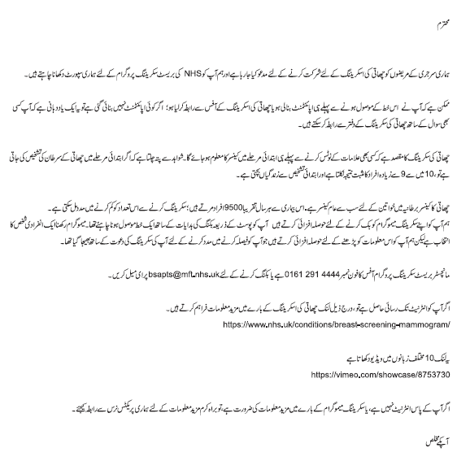

[Insert Dr’s name and electronic signature]

