Private & Confidential

Date

Name
Address 1
Address 2
Postcode

Dear <<patient name>>

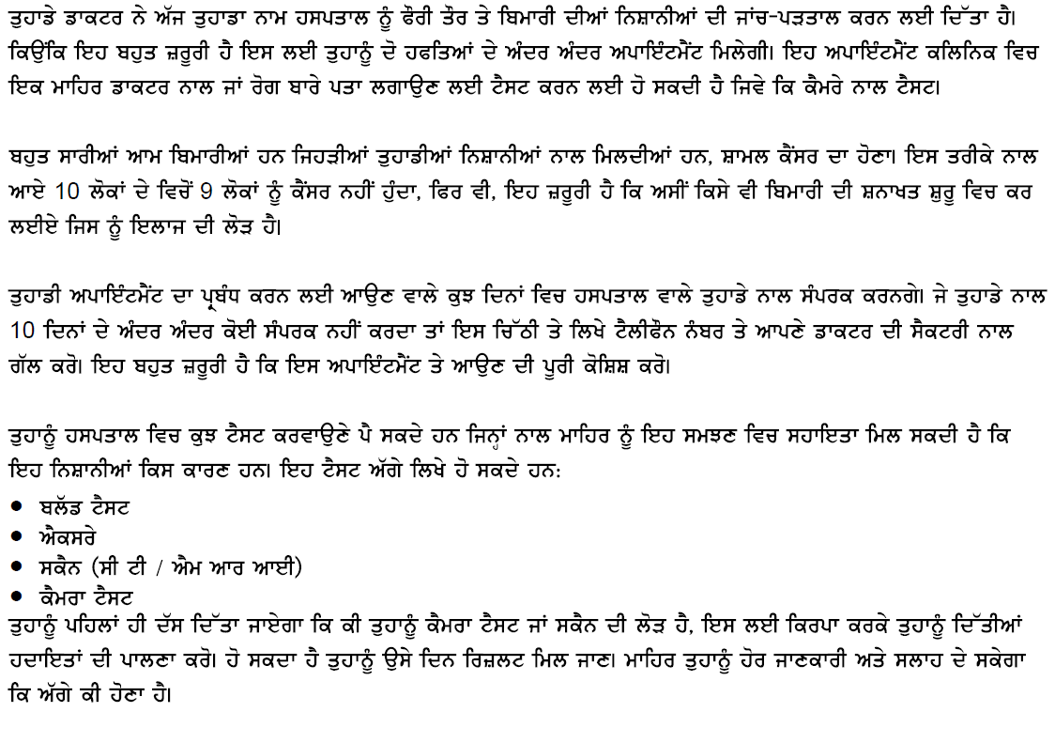
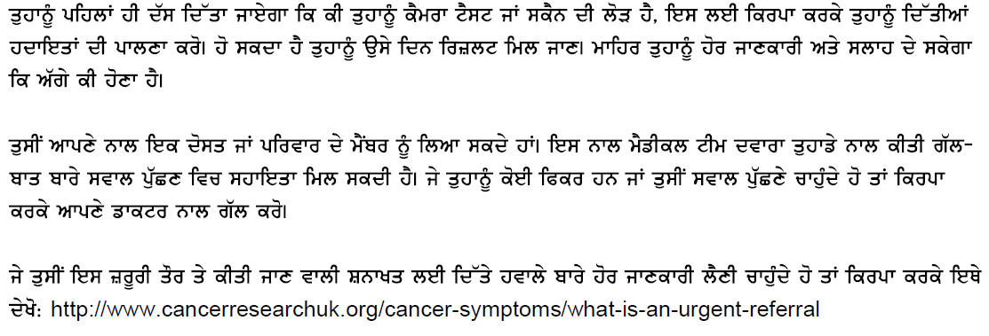

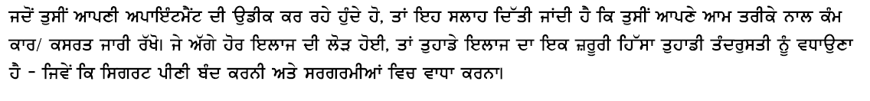

<< GP>>
Surgery contact details

