Dear <<patient name>>

This letter is to let you know you are close to the age we will need to ask you to book a cervical smear test. This test checks the cells in your cervix are healthy. If we see unhealthy cells, we can catch them early, so they don’t turn into cancer.

Information about HPV
HPV is a virus that can show up in your cervical smear test. HPV is not dangerous, but it can change the shape of your cells. If we don’t check for HPV then this can turn into cervical cancer.

You can catch HPV from having sex or not having sex. Men can pass on the virus but not have any symptoms. You might have HPV and not know about it. But we still need to check.

If we find cells that look different, we will ask you to come to the hospital for more checks.

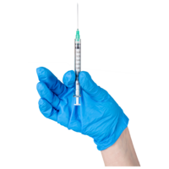
What happens if I have already had the HPV vaccine

If you have had the HPV vaccine at school, we still need you to come for a cervical smear test.
The vaccine will keep you save from most HPV viruses but not all of them.

This test is not to look for cancer. We just need to know your cervix is healthy and all the cells look normal. We do this test so we can catch cancer early, if it shows on your results.

We can’t do the test until you are 24 and a half years old. You will get a letter from us asking you to book at test with your GP.

If there is anything you are worried about or you have any questions, then please ask me.

Thank you

Your doctor

