Dear <<patient name>>
This letter is about your cervical screening test. This is a test to check the cells in your cervix are healthy. If we see unhealthy cells, we can catch them early, so they don’t turn into cancer.

Every woman should have a cervical screening test. The risk of cancer can get bigger if you are an older woman. So, we need you to come and get checked.

We know the test can feel a bit embarrassing. But it doesn’t take long and the nurse who does the test will make you feel safe and relaxed.

Information about HPV

HPV is a virus that can show up in your cervical screening test. HPV is not dangerous, but it can change the shape of your cells. If we don’t check for HPV then this can turn into cervical cancer.

You can catch HPV from having sex or not
having sex. Men can pass on the virus but not have any symptoms. You might have HPV and not even know about it. But we still need to check.
Booking an appointment

If you have missed an appointment before, that is OK. You can still book another one with your GP using the booking system.

You can book an appointment to talk to the nurse about the test. She can make you feel more comfortable about the test and you can ask questions.
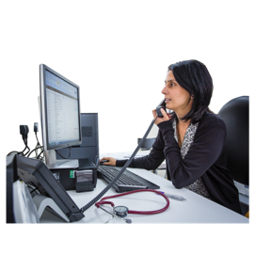
Anything you say and your questions are private. We will not tell anyone what these are.

Please make an appointment as soon as you
can.

Thank you

Your doctor

