Dear <<patient name>>
This letter is about your cervical smear test. We need you to come for a test check the cells in your cervix are healthy. If we see unhealthy
cells, we can catch them early, so they don’t turn into cancer.

If you are between 24 and a half and 65 years old then you should have a cervical smear.
Cervical cancer is most common for women under 35 years old so we need you to come and get checked.

We know the test can feel a bit embarrassing. But it doesn’t take long and the nurse who does the test will make you feel safe and relaxed.
Information about HPV

HPV is a virus that can show up in your cervical smear test. HPV is not dangerous, but it can change the shape of your cells. If we don’t check for HPV then this can turn into cervical cancer.

You can catch HPV from having sex or not having sex. Men can pass on the virus but not
have any symptoms. You might have HPV and not know about it. But we still need to check.

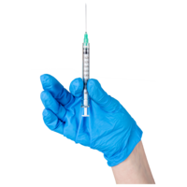
Most HPV viruses disappear on their own. But some are more high risk and can stay in your body for years. You should still come for a test, even if you had the HPV vaccine at school.

We will test your cell sample at the laboratory. If we see your cells look different, we will do more tests at the hospital.

Booking an appointment
This might be your first cervical smear test or you may have already missed appointments.

You can book an appointment to talk to the nurse about the test. She can make you feel more comfortable and you can ask questions.
Anything you say and your questions are private. Please make an appointment as soon as you can.

Thank you

Your doctor

